**Comparing Data Transfer Speeds with S3 Transfer Acceleration**

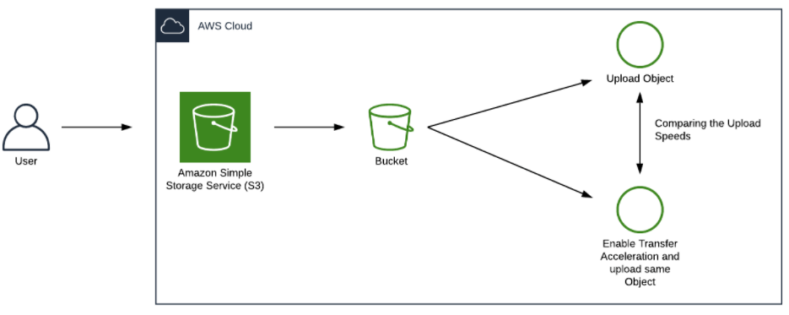

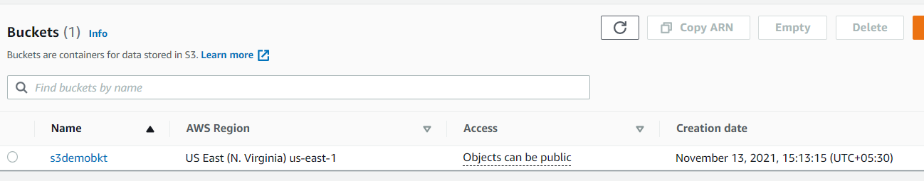

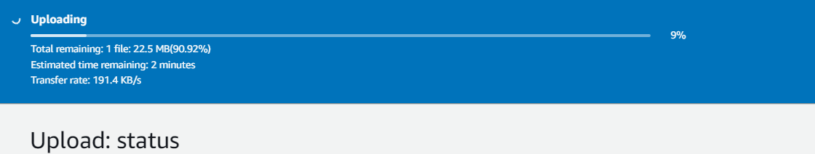

**Direct upload taken 180 sec for 28mb file.**

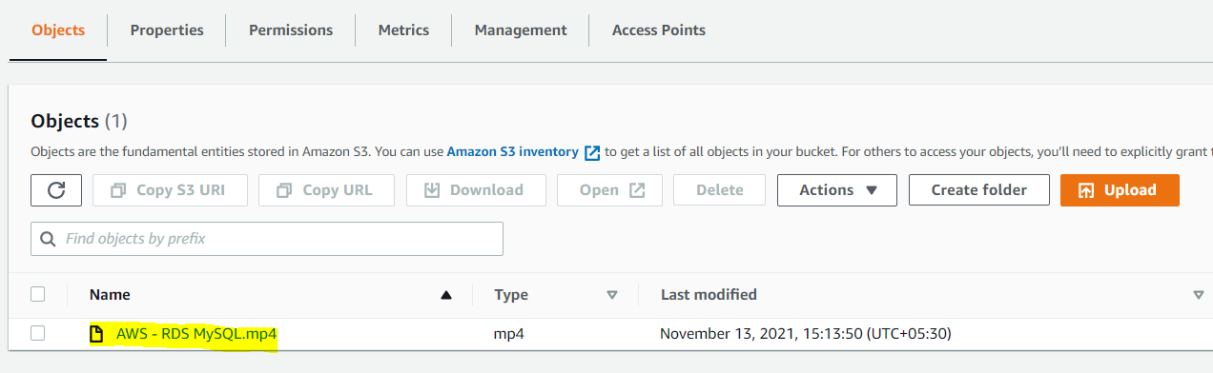

**Let try uploading Transfer acceleration**

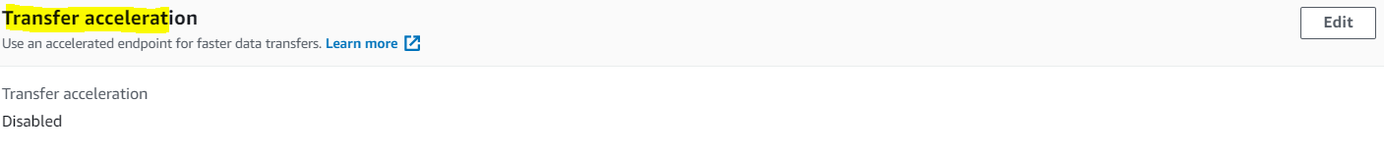

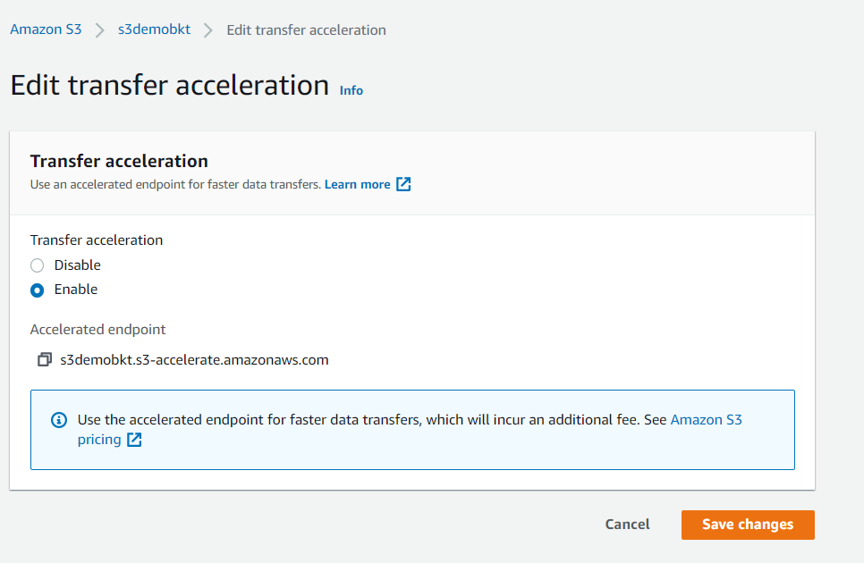

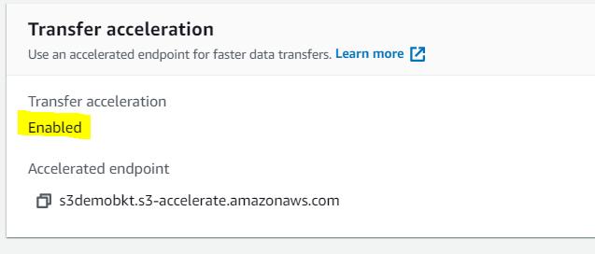

**Using transfer acceleration taken only 90 sec.**